 | ALL SAINTS’ COLLEGE  Ewing Avenue, Bull Creek, Western Australia
 | HUMAN BIOLOGY

Year 11 2007 - Semester I Examination - Question/Answer Booklet
C.C. STUDENT NUMBER - In figures 

TIME ALLOWED FOR THIS PAPER
Reading time before commencing work: Ten minutes
Working time for paper: Two hours thirty minutes

MATERIAL REQUIRED/RECOMMENDED FOR THIS PAPER
TO BE PROVIDED BY THE SUPERVISOR
This Question/Answer Booklet
Standard Answer Booklet
Multiple Choice Answer Sheet

TO BE PROVIDED BY THE CANDIDATE
Standard Items: Pens, pencils, eraser and ruler.
Special Items: A 2B, B or HB pencil for the separate Multiple Choice Answer Sheet and calculators satisfying the conditions set by the Curriculum Council.

INSTRUCTIONS TO CANDIDATES

See page 2.

IMPORTANT NOTE TO CANDIDATES
No other items may be taken into the examination room.
It is your responsibility to ensure that you do not have any unauthorised notes or other items of a non-personal nature in the examination room. If you have any unauthorised material with you hand it to the supervisor BEFORE reading any further.

SEE PAGE 2
STRUCTURE OF THIS PAPER

Part | No. of questions  available | No. of questions to be attempted | Marks available
I Multiple Choice  II Diagram and Short Answer questions  III Extended answer questions: | 40  6  2 | ALL  ALL  1 | 80  80  20

Total Marks = 180 → 100%

INSTRUCTIONS TO CANDIDATES

PART I Should be answered on the separate Multiple Choice Answer Sheet. Use a 2B, B or HB pencil, NOT A BALL POINT OR INK PEN.

PART II Should be answered in this Question/Answer Booklet. Write your answers in the spaces provided, using a blue or black ballpoint or ink pen. Draw any diagrams in pencil.

PART III Should be answered in the Standard Answer Booklet.

Make sure your Curriculum Council Student Number is on your Multiple Choice Answer Sheet, this Question/Answer Booklet and the Extended Answer Booklet.

PART I (80 Marks)

Suggested time : 60 minutes.
Mark your answers to Questions 1 – 40 on the SEPARATE MULTIPLE CHOICE ANSWER SHEET, using a 2B, B or HB pencil. If you make an error follow the instructions given to you on your answer sheet.

1. The digested and absorbed food substances are used for which of the following purposes?

1. for growth
2. for repairing body tissues
3. for providing energy
4. for producing water
A 1 and 3.
B 2 and 4.
C 1, 2 and 3.
D 1 only.

2. The table below shows the vitamin C contents of potatoes.

 | Vitamin C (milligrams/100 g)
Fresh potatoes  Stored potatoes  Fresh, roast potatoes  Fresh, boiled potatoes  Stored, boiled potatoes | 30  8  7  18  5

Which one of the following statements agrees with the figures?
A The method of cooking does not affect the degree of Vitamin C destruction.
B Vitamin C is only present in fresh foods.
C Cooking destroys some Vitamin C.
D Boiling destroys more vitamins than roasting.

3. Which one of the following pairs of features is unique to the vertebrate class to which humans belong?
A Warm blood and internal skeleton.
B Four limbs and special sense organs.
C Omnivorous and young cared for by parents.
D Placenta and hairy skin.

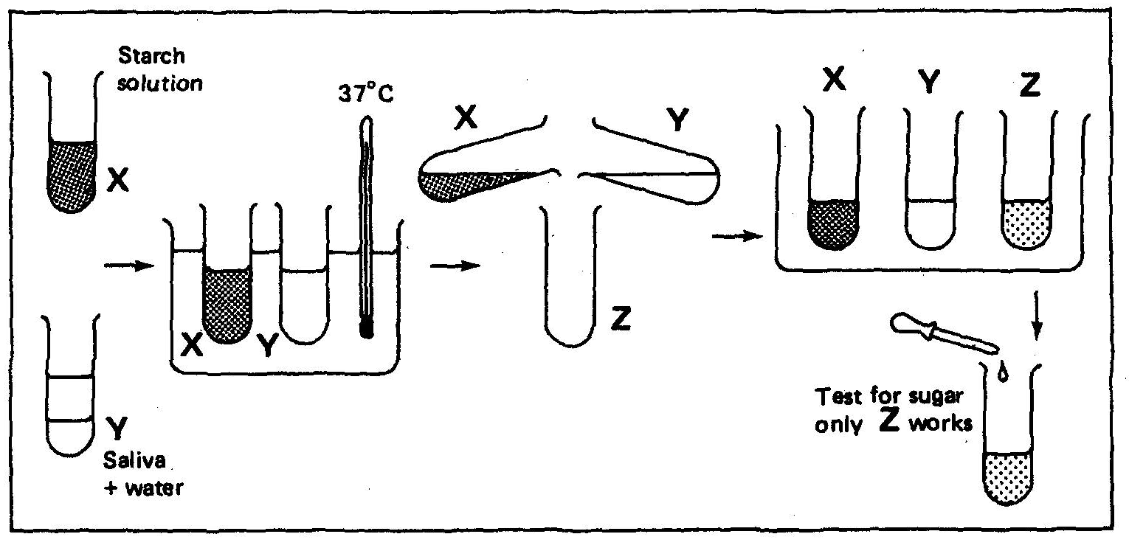
Questions 4 to 7 refer to the diagram below which shows a way of finding out what happens to starch when it is mixed with saliva in our mouths.

4. At the end, test tube Z contained
1. starch.
2. saliva.
3. water.
A 1, 2 and 3.
B 1 and 2.
C 2 and 3.
D 1 only.

5. All three test-tubes had to be tested because
1. the starch could have contained sugar to start with.
2. the saliva could have contained sugar to start with.
3. the test-tubes could have been dirty.
A 1, 2 and 3.
B 1 and 2.
C 2 and 3.
D 1 only.

6. The experiment tells us that
1. saliva can turn starch into sugar.
2. wetting starch changes it into sugar.
3. heating saliva changes it into sugar.
A 1, 2 and 3.
B 1 and 2.
C 2 and 3.
D 1 only.
7. Tubes X and Y were put in a water bath
1. to dissolve the starch.
2. to make the starch into sugar.
3. to heat them to mouth temperature.
A 1, 2 and 3.
B 1 and 2.
C 2 and 3.
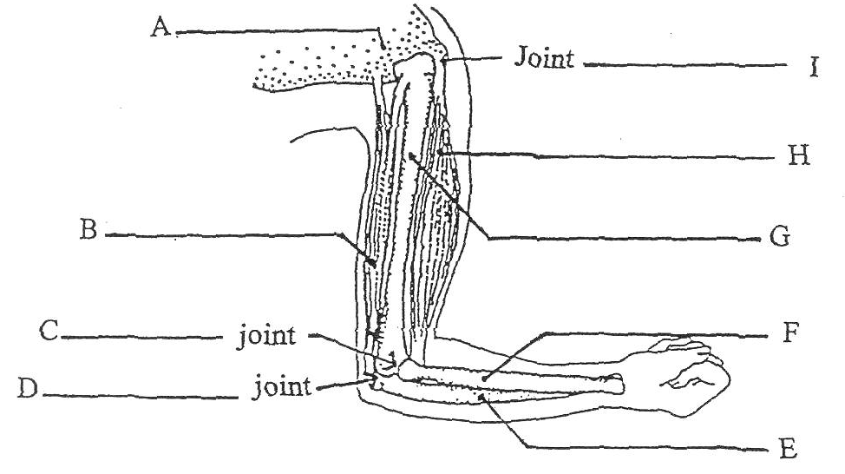
D 3 only.

8. In the diagram on the right, the bone labelled F is the

A radius.
B ulna.
C humerus.
D carpal.

9. The opposing movements brought about by muscles B and H is termed
A synergistic.
B antagonistic.
C extension.
D flexion.

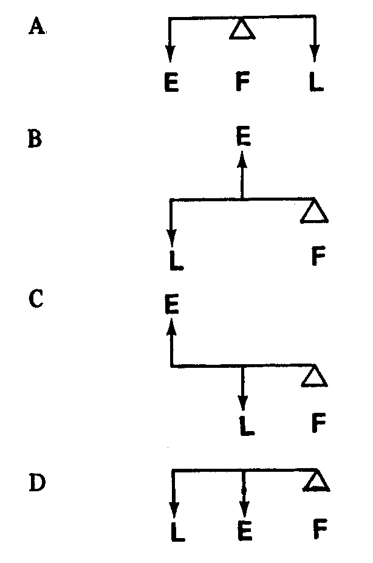
10. Which diagram represents the type of lever found in the bending of an arm?

The human dentition is shown below. Use it to answer questions 11 – 13.
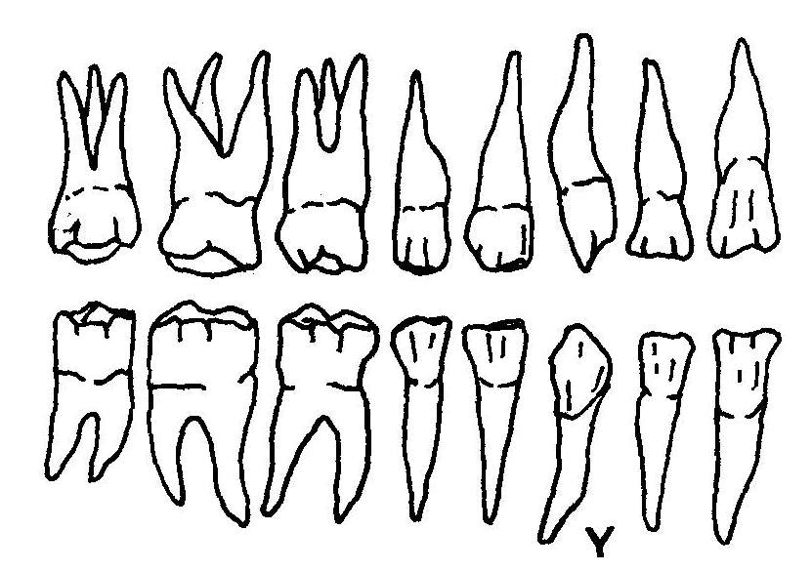
11. The correct dental formula of the above dentition is
A m, pm, c, i
B i, c, pm, m
C i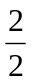, c, pm, m
D i, c, pm, m

12. With reference to the above dentition, the total number of teeth in humans is
A 16.
B 30.
C 40.
D None of the above.

13. Tooth Y is usually well developed in
A apes as they are meat-eaters.
B gorillas for offence and defence.
C lemurs as a grooming tool.
D humans to suit their onmivorous diet.

14. Which of the following can be determined as risk factors for heart attacks?
1. Low blood pressure
2. High blood pressure
3. Starvation
4. Lack of exercise
5. Smoking
6. Obesity
7. High fat diet

A 1, 3, 5 and 7.
B 2, 4, 6 and 7.
C 2, 4, 5, 6 and 7.
D 1, 2, 5, 6, 7.

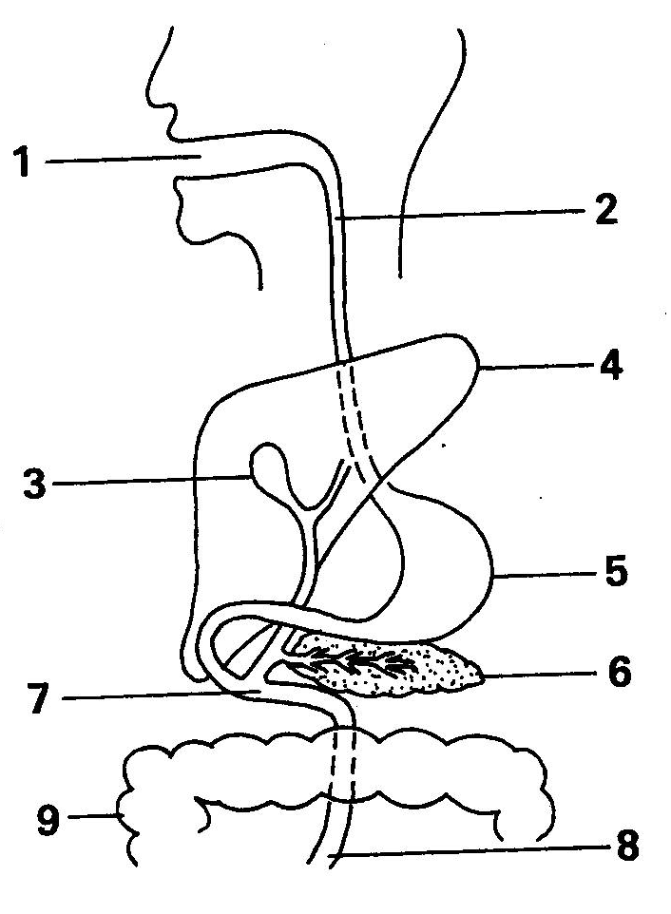
15. The diagram above shows the alimentary canal and other digestive organs. Which of them are involved in the digestion of lipids?
A 2, 3, 6, 7, 9.
B 3, 6, 7, 8.
C 1, 2, 3, 6, 9.
D 2, 7, 8, 9.

16. It is true to say of the renal vein that it
1. has no dissolved sugar.
2. contains little urea.
3. contains much carbon dioxide.
4. contains little oxygen.
A 1, 2 and 3.
B 1, 2 and 4.
C 2, 3 and 4.
D 1 and 4.
17. Blood capillaries in villi → X → liver. The arrow represents the flow of blood from left to right. What is X?

A Hepatic vein.
B Hepatic portal vein.
C Lymph vessel.
D Lacteal.

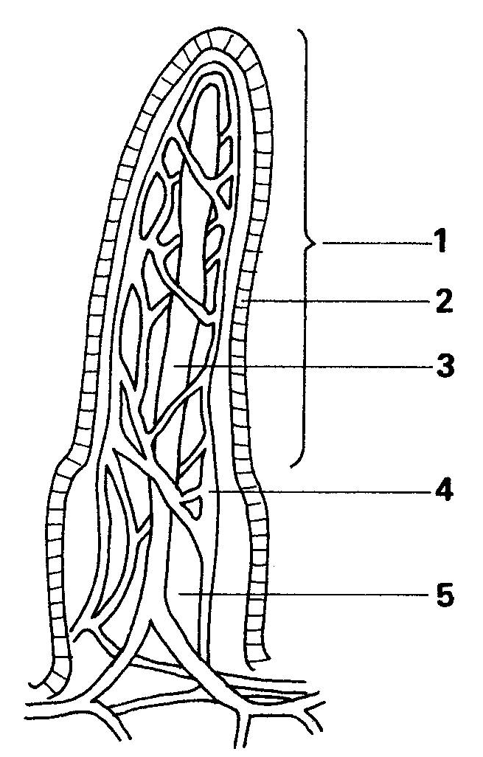
Questions 18 and 19 refer to the diagram below which shows a structure found in the human body.

18. The structure represented by the diagram is present in the
A caecum.
B large intestine.
C oesophagus.
D small intestine.

19. Digested food can enter the structure labelled 4 by
1. osmosis.
2. diffusion
3. active transport
A 1 and 2.
B 2 and 3.
C 1 and 3.
D 1, 2 and 3.

20. Of the primates it is true that
1. lemurs are amongst the most primitive.
2. most are arboreal.
3. they only walk on their hind limbs.
4. humans are a member of the group.
A 1, 2 and 3.
B 1, 2 and 4.
C 2, 3 and 4.
D 1 and 4.

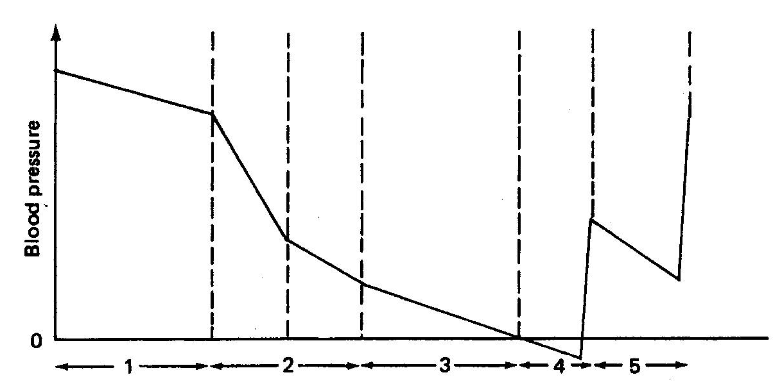
21. The graph below shows the mean blood pressure in various vessels in the human circulatory system.

Which of the following gives the correct names of 1, 2, 3, 4 and 5 on the graph?
1 2 3 4 5
A lungs arteries veins capillaries arteries
B arteries capillaries veins vena cava lungs
C capillaries arteries vena cava lungs veins
D vena cava veins capillaries lungs arteries

22. Medical research has shown that African villagers eliminate an average 250g of faeces each day compared with 110g for people living in the United Kingdom. In addition, harmless plastic pellets swallowed by Africans passed through their alimentary canals almost twice as quickly. The most likely explanation for these differences is that the normal diet of an African villager contains much more

A protein.
B starch.
C dietary fibre.
D water.

Questions 23 and 24 refer to the following table.
Types of bones | Examples
long  short  flat  irregular | X  tarsals  Y  vertebrate

23. An example of X is the
A phalanges.
B femur.
C carpals.
D mandible.

24. An example of Y is the
A scapula.
B patella.
C tibia.
D clavicle.

25. Select the correct sequence for the blood flow in humans from the diagram below.
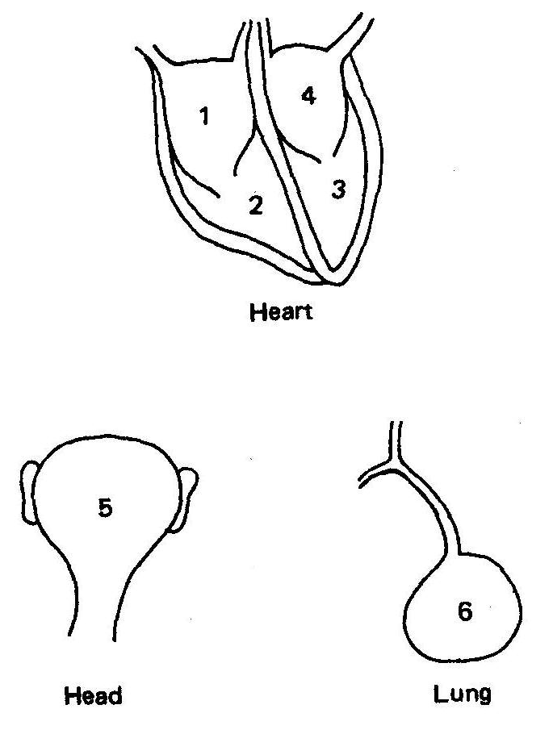
A 1, 2, 6, 5, 4, 3
B 4, 3, 5, 6, 1, 2
C 1, 2, 4, 3, 5, 6
D 6, 4, 3, 5, 1, 2

26. Between which of the following pairs of bones is there free movement in most directions?
A Radius and humerus.
B Ulna and humerus.
C Radius and scapula.
D Humerus and scapula.

27. A pulse is best described as
A pulsation of a blood vessel over a bone.
B rhythmical movement of blood through a vein.
C rhythmical elastic distension of an artery near the body surface.
D rhythmical muscular contractions of an artery near the body surface.

Questions 28 and 29 refer to the following information.
The table shows the number of formed elements in blood samples taken from four different people. Two of the samples are from individuals with health problems. The normal amounts are indicated thus * once in the table.

Type of Cell | A | B | C | D
Red blood cells  (cells/mL) | 500 000 | 7 500 000 | 5 000 000* | 2 000 000
White blood cells  (cells/mL) | 500 | 7 000 * | 10 000 | 7 000
Platelets  (number/mL) | 250 000 * | 250 000 | 250 000 | 50 000

28. Which of the individuals has probably recently spent time at a high altitude?
A A.
B B.
C C.
D D.

29. Which of the individuals is suffering, or has recently recovered from, an infectious disease?
A A.
B B.
C C.
D D.

30. Refer to the following table.
Number | Structure
1 | Larynx
2 | Bronchioles
3 | Pharynx
4 | Bronchi
5 | Trachea
6 | Nasal Cavity

When air is inhaled it flows through the various structures in the following order
A 6, 5, 4, 3, 2, 1
B 6, 4, 1, 5, 3, 2
C 6, 3, 1, 5, 4, 2
D 6, 4, 2, 5, 3, 1

Questions 31, 32 and 33 refer to the following information.

The data presented below was recorded in an experiment where a subject breathed in and out of a paper bag and the percentage of carbon dioxide in the air in the bag was recorded. The rate and depth of breathing of the subject was also measured.

 | Normal breathing | After rebreathing
% of CO₂ in bag | 0⋅4 | 1⋅52
Depth of breathing | 673 mL | 7⋅94 mL
Rate of breathing | 14/min | 15/min

31. Given the data above, the volume of air breathed by the subject in one minute of normal breathing is

A 9422 L.
B 9422 mL.
C 40 L.
D 40 mL.

32. What was the percentage change in the depth of breathing between normal breathing and rebreathing?

A 8⋅4%.
B 84⋅7%.
C 1⋅1%.
D 40⋅6%.

33. The percentage of oxygen found in inspired air is
A 16%.
B 4⋅3%.
C 21%.
D 0⋅4%.

34. In a large study to investigate a possible association between blood groups and the incidence of duodenal ulcers, doctors in different parts of the world obtained the following data showing the percentage of a group of healthy indidivuals and of individuals suffering with duodenal ulcers, having blood groups O or A :

Country | Healthy Population | Duodenal Ulcer Patients
 | Blood Group  O A | Blood Group  O A
United Kingdom | 45⋅8% 44⋅2% | 56⋅6% 32⋅9%
America | 45⋅8% 41⋅6% | 53⋅7% 36⋅3%
Italy | 36⋅3% 44⋅2% | 41⋅0% 41⋅3%
Australia | 53⋅9% 32⋅3% | 57⋅7% 31⋅5%

From the above data it appears that those with the greatest risk of developing a duodenal ulcer are people with blood group
A O in the United Kingdom.
B A in America.
C A in Italy.
D O in Australia.

35. Which one of the following allows the lungs to move freely and without friction between the inner walls of the thorax?
A Mucus within the bronchioles.
B Fluid within the pleura.
C Moisture in inhaled air.
D The blood supply.

36. Before starting mouth-to-mouth resuscitation
A five quick breaths should be given.
B the circulation should be checked using the carotid pulse.
C the airway should be checked to make sure there are no obstructions.
D the head should be tilted back.

Use these diagrams to answer questions 37 – 39.

The following are all primates.
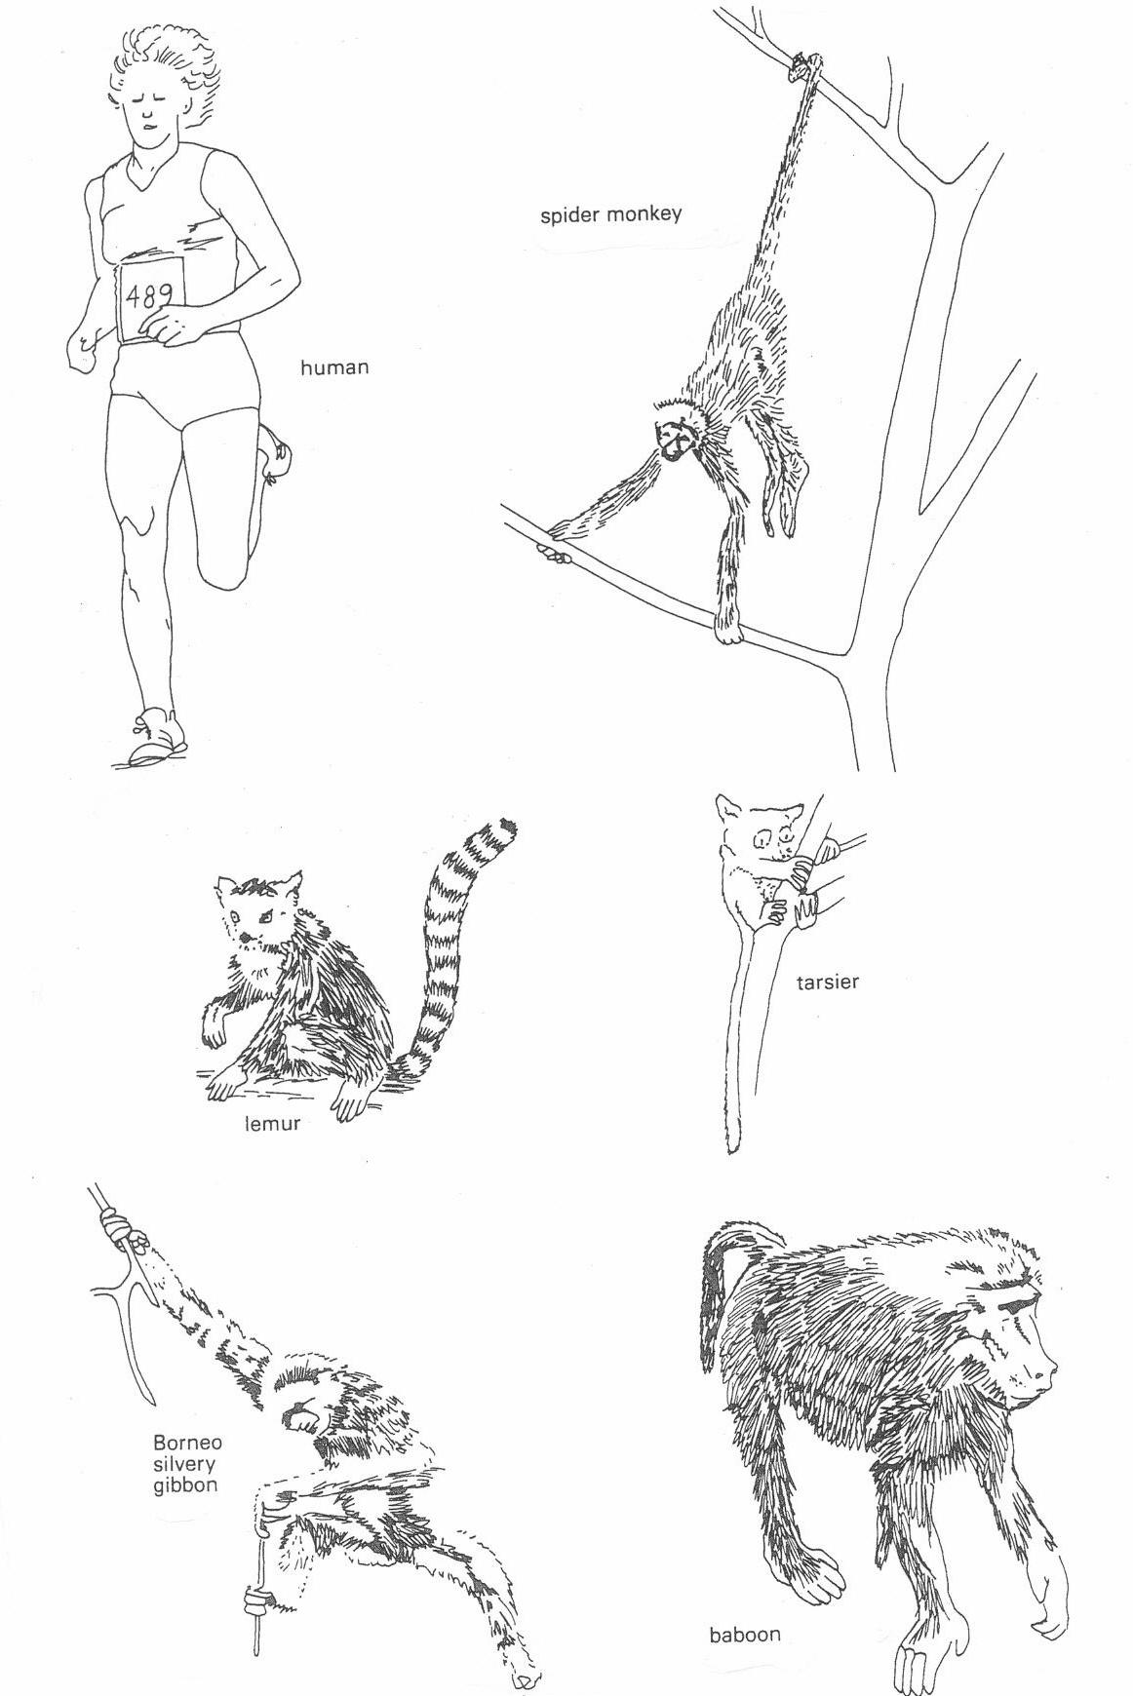

37. Which of the following pairs are most closely related?
A Lemur and spider monkey.
B Gibbon and spider monkey.
C Gibbon and human.
D gibbon and baboon.
38. Which of these animals is most likely to have ischial callosities?
A Lemur.
B Tarsier.
C Gibbon.
D Baboon.

39. Which of these animals is nocturnal?
A Spider monkey.
B Lemur.
C Tarsier.
D Gibbon.

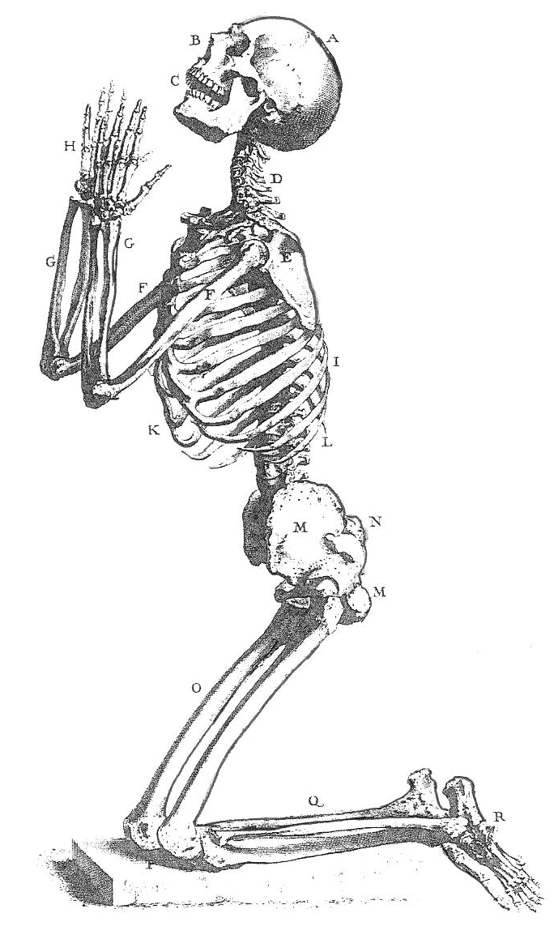
40. Which of the following names correctly identifies the
labelled bones?

Select | Bones
from | D | H | Q | R
A | cervical  vertebra | phalanges | fibula | tarsals
B | thoracic vertebra | metacarpals | femur | metatarsals
C | cervical vertebra | carpals | tibia | tarsals
D | cranial vertebra | radials | fibia | transverse arch

END OF PART I
PART II : Diagram and Short Answer Questions. (80 MARKS)

Suggested time : 60 minutes.

Write answers to ALL questions on the ruled lines after each question or in the spaces provided.

Write your answers in blue or black ballpoint or ink pen. Draw diagrams in pencil.

41. (12 Marks)
Study the diagrams below and use the information shown to answer the questions.
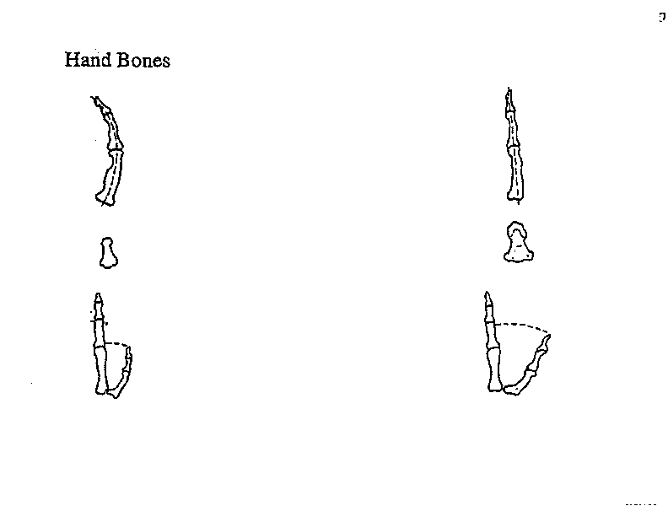

A. Gorilla B. Human

(a) Comment on the manipulative ability of each hand giving a reason for your answer.
(2m)
______________________________________________________________________

(b) The thumb bones of a human are jointed in a special manner. Name the type of joint and describe the movement it allows. (2m)
______________________________________________________________________
41. (ctd)
Skull and Jaws
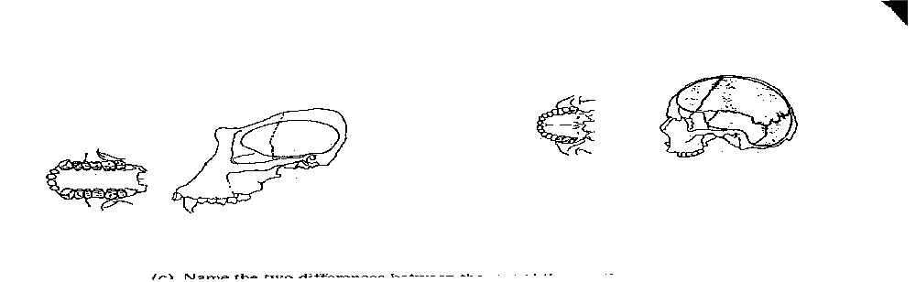

A. Gorilla B. Human

(c) Name the two differences between the jaw of the gorilla and the human.
(i) __________________________________________________________________ __________________________________________________________________

(ii) __________________________________________________________________

__________________________________________________________________
(2m)

(d) Name one difference in lifestyle that you could infer by examining the jaw and skull of these two primates. Give a reason for your answer.
(2m)

41. (ctd)
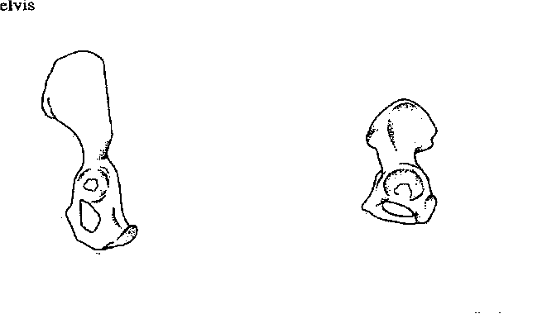 Pelvis

A. Gorilla B. Human

(e) What can be inferred about the stance of the gorilla and the human by examining the pelvis of each? Give a reason for your answer. (2m)
___________________________________________________________________
___________________________________________________________________

(f) Gorillas and humans are both classified as Primates. Name two characteristics that enable this classification to be made. (2m)

1. _______________________________________________________________

2. _______________________________________________________________

42. (11 Marks)
For a period of several hours after a meal, samples of food were taken from the parts of the digestive system labelled 1 – 6 in the diagram below.
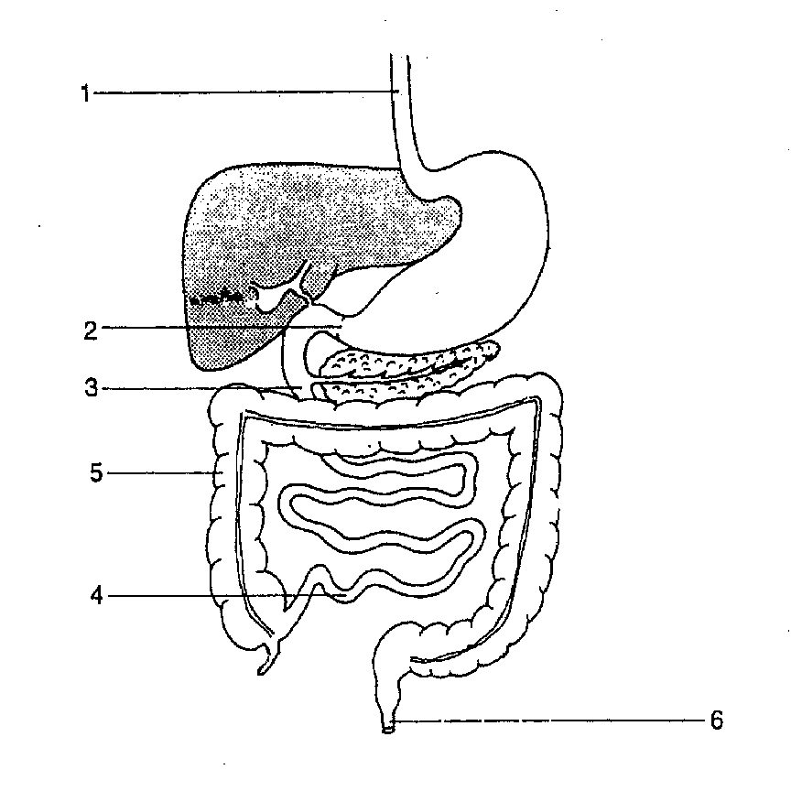
The samples were analysed and the results are shown in the table below.

Substances in sample | Parts of the digestive system sampled
Substances in sample | 1 | 2 | 3 | 4 | 5 | 6
% Starch | 8 | 7 | 0 | 0 | 0 | 0
% Sugars | 2 | 1 | 8 | 0 | 0 | 0
% Proteins | 5 | 1 | 9 | 0 | 0 | 0
% Amino Acids | 0 | 2 | 3 | 0 | 0 | 0
% Fats | 5 | 4 | 2 | 0 | 0 | 0
% Water | 70 | 76 | 76 | 89 | 80 | 70
% Fibre | 10 | 9 | 9 | 11 | 20 | 30
pH | 7 | 3 | 8 | 8 | 8 | 8

(a) This data is taken from a person who was on a sugar-free diet. What evidence is there in the table to support the recorded observation that there must be an amylase in the mouth? (2m)

42. (b) Suggest two reasons why there are no amino acids in the sample from Part 1.
(2m)

(c) What has caused the change in pH between Part 1 and Part 2? (1m)

(d) (i) In what numbered part or parts is the greatest variety of nutrients digested?
(1m)

(ii) Explain how the data in the table enabled you to determine your answer to d(i). (2m)

(e) Explain the readings showing the % of fibre for each part tested. (3m)

43. (10 Marks)
Every cell in the human body is dependent on enzymes for its proper functioning.
(a) Define the term enzyme. (2m)

(b) In a classroom experiment, test tubes containing a particular enzyme and its substrate were placed in water baths at different temperatures. The reaction was stopped after a given time and the amount of product formed was measured. From the results, enzyme activities at temperatures between 15 and 45 degrees Celsius were calculated, and are shown in the table below.

Temperature °C | Enzyme Activity  (International Units)
15 | 12
20 | 18
25 | 28
27 | 35
31 | 42
34 | 77
37 | 95
39 | 90
41 | 76
45 | 24

(i) Plot a line graph on the graph paper provided. (5m)

(ii) Describe how and why the activity of this enzyme varied between 15 and 45°C? (2m)

(iii) Calculate the percentage increase in enzyme activity between 27 and 37°C?
(1m)

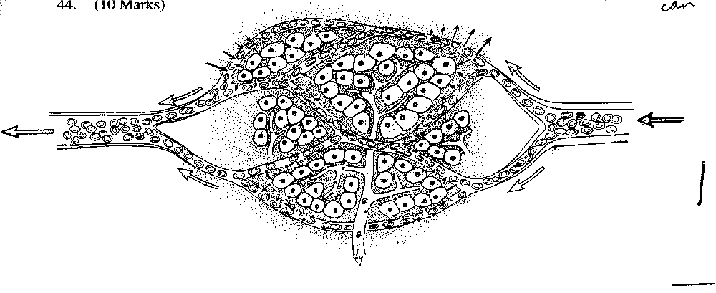44. (10 Marks)

(a) On the diagram above, label the following :
capillary, arteriole, venule, lymph vessel, tissue fluid, blood, erythrocyte, intracellular fluid. (4m)

(b) Where would you find such a feature in the body? (1m)

(c) Name two substances entering the capillaries from the cells. (2m)

(d) Name the location where the contents of the lymph vessels empty into the circulatory system. (1m)

(e) Describe two functions of the lymph system. (2m)
1. _____________________________________________________________

2. _____________________________________________________________
45. (20 Marks)
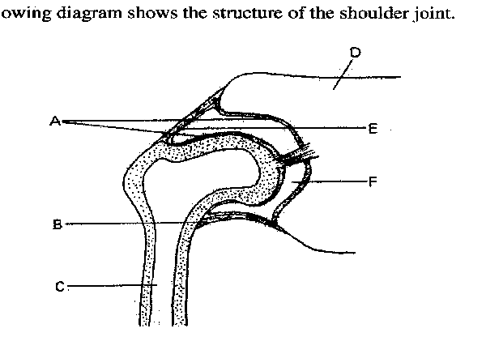 The following diagram shows the structure of the shoulder joint.

(a) Name the parts labelled A – F. (6m)
A _______________ D _______________
B _______________ E _______________
C _______________ F _______________

(b) (i) What type of joint is it? (1m)
_________________________________________________________________

(ii) What is the range of movements permitted by this joint? (1m)
_________________________________________________________________

(iii) Why is this an advantage to primates? (1m)
_________________________________________________________________
_________________________________________________________________

(c) (i) What is the function of A? (1m)
_________________________________________________________________
_________________________________________________________________
(ii) Describe one way the tissue in A differs from that in C. (1m)
_________________________________________________________________
_________________________________________________________________
45. (d) What is the function B? (1m)

(e) Explain the structure of E. (1m)

(f) There are two other general types of joints. One is found in the skull, the other joining the ribs and sternum. Fill in the following table.
(4m)
Example of joint | Name of general type of joint | Type of movement allowed
Between bones of the skull
Between sternum and ribs

(g) A sprinter is 70m through a 100m race. Suddenly she feels a sharp pain in the back of her lower right leg. She finds she can no longer walk. On examination, a doctor finds no evidence of muscle or bone damage to the leg.

What structure has she damaged? _____________________________ (1m)

Besides the pain, describe why she cannot actually walk. (2m)

46. (17 Marks)
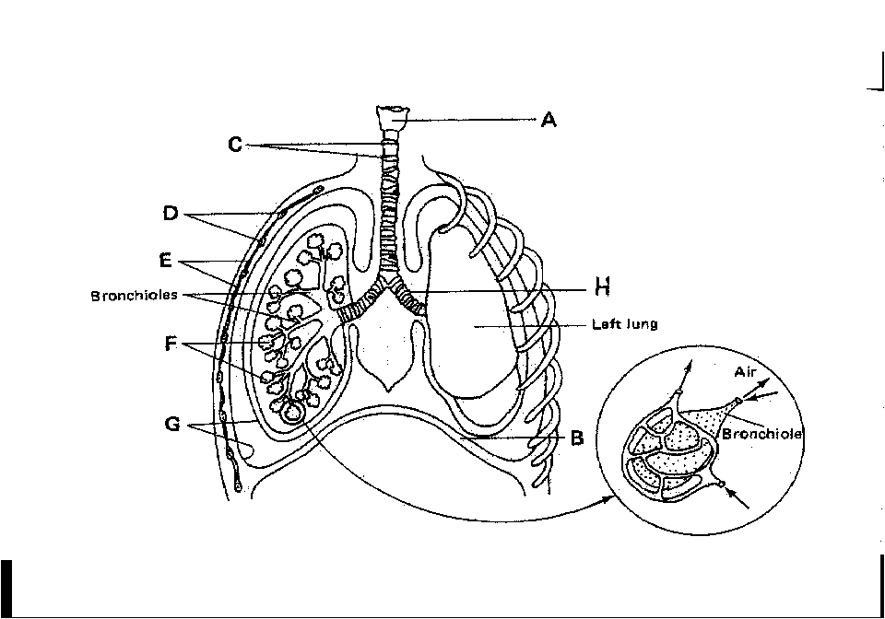
(a) Name the following parts.
A _______________ F _______________
B _______________ G _______________
C _______________ (5m)

(b) Explain the following statements :
(i) "It is not possible to swallow and breathe at the same time." (1m)

(ii) "It is more advisable to breathe through the nose instead of the
mouth." (2m)
_________________________________________________________________
_________________________________________________________________

(c) Give one function of :
(i) structure C ___________________________________________________
_____________________________________________________________
(ii) structure G ___________________________________________________
_____________________________________________________________
(2m)

46. (d) Explain the role of B and E when a person is breathing out. (3m)

(e) Describe two features of structure F (as shown in the enlarged
diagram) and explain how the feature aids the function of the lung.

Feature of structure F | How it helps the function of the lung

(4m)

END OF PART II
PART III
Suggested time : 30 minutes. (20 marks)

Answer one question only. Illustrate your answer with diagrams where appropriate. Up to two marks may be deducted for poorly structured answers : that is, answers in point form or diagrams not explained in the text of your answers. DO NOT WRITE ANSWERS IN PENCIL. Write your answers on the lined pages in your Separate Answer Booklet.

Answer either Question 47 or Question 48 – NOT BOTH.

47. Describe the structure of each of the following components of the circulatory system and relate this to the function each performs.

- The blood vessels (the arteries, capillaries and veins).
- The blood (the fluid and blood cells).
(20 Marks)

O R

48. A student eats a cheese sandwich (buttered bread) for lunch. Explain the digestion of the food under the following headings :

- chemical groups broken down.
- enzymes involved.
- products produced.
- sites of digestion and absorption

(20 Marks)

END OF EXAMINATION

